**Deliverable 5**

Design 2

Team 2

MCU TNC Design

Kaleb Leon – C00094357

Kobe Keopraseuth – C00092349

David Cain – C00043561

November 2nd, 2020

1. *Current Comprehensive Testing Tree Progress*

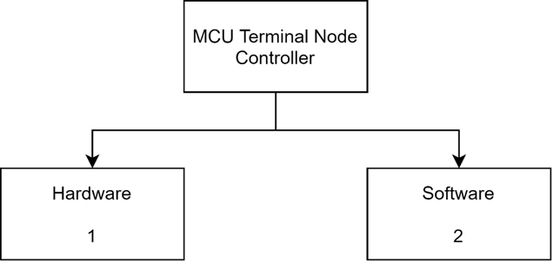

*Figure F-1. High Level Comprehensive Testing Tree*

*Figure F-2. Hardware Comprehensive Testing Tree*

*Figure F-3. Software Comprehensive Testing Tree*

1. *Completed Testing Forms*